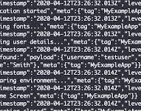

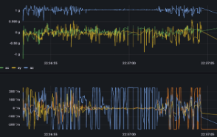



Investigate and trace logs when issues occurred
Produce logs and details of each request
Wrap-up PM data (diagram metrics) to Grafana
Live update dashboard
Log into dashboard – eg. 12x factor
Response based on the requests - does MCP or NCS provide streaming / live services?
Rest API requests to request PM data
Streaming – continuous and consistent requests

